**Innovation Management Apr 13th, 2023 (20 points)[1]**

**Q1 - (6 pt) Commentary**

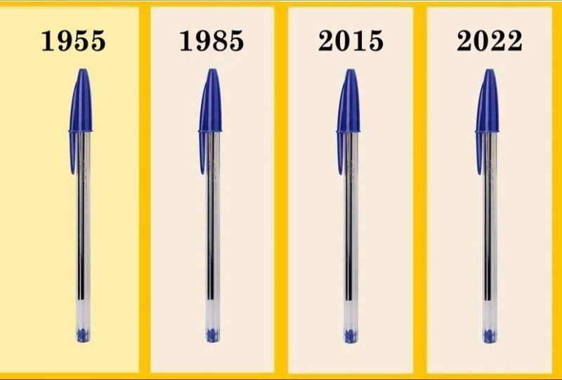

*The BIC Cristal (stylised as BiC Cristal and also known as the Bic pen) is an inexpensive, disposable ballpoint pen mass-produced and sold by Société Bic of Clichy, Hauts-de-Seine, France. It was introduced in December 1950 (72 years ago) and is the best-selling pen in the world, with the 100 billionth sold in September 2006. It has become the archetypal ballpoint pen and is considered ubiquitous, to the extent that the Museum of Modern Art has made it a permanent part of its collection. Its hexagonal form and design mimics a standard pencil and it is sold in six types of point and 18 colours around the world. (source: Wikipedia)*

You've probably seen this picture of BIC pens remained unchanged over the years, that is often used as a case supporting statements such as:

- Don't change something as long as it's still working.

- Sometimes there is no need to innovate!

- The same lovely old pen has worked well for years!

- If it runs out of ink, just buy another one!

These are typical statements of managers concluding that *a wise leader does not touch what works well*.

These managers probably discount the fact that today's world is riding the digital wave filled with rapid changes in technology, markets, and many other factors that may influence long term competitive advantage.

Based on the theory of organizational learning and on the concept of the “innovator’s dilemma” discussed in class, write a short commentary that covers the following points:

1. What kind of manager thinks and acts like this?
2. What kind of companies typically face this problem?
3. What could be the risk?
4. What is the main trade-off that such companies face, and what are the mechanisms that could solve it?

**Q2 - (4pt) Open question:** Diffusion of Innovation is a theory that seeks to explain how, why, and at what rate new ideas and technologies spread. It was Everett Rogers, a professor of communication studies, who popularized the theory in his book “Diffusion of Innovations”. Rogers argues that diffusion is the process by which an innovation is communicated over time among the participants in a social system. 5 segments are profiled, with regard to their attitude towards innovation: innovators (Lead users, enthusiasts), visionaries (early adopters), pragmatists (early majority) conservatives (late majority) and skeptical (laggards).

Explain why, in the case of a tech company in its startup stage, early adopters could represent a crucial segment to cover, and substantiate your answer with a real-life example.

**Q3 - (2pt) Closed question: When using Porter’s five forces model, the introduction of innovations should be taken into account, since they have a strong influence on … (select the correct answer)**

[ The threat of new entrants: when new competitors may enter easily, incumbent businesses risk losing market share because competition in the industry increases.

[] The negotiating power of customers, as it lowers their “buyer power.”

[] The negotiating power of suppliers, as it lowers switching costs and raises the threat of substitute products

[] All the five forces, since all of them can be influenced by innovations.

**Q4 – (2pt) Closed question: Stage-Gate processes in new product development are based on the principle that…. (select the correct answer)**

[ costs increase and uncertainty decreases with time

[] costs decrease and uncertainty increases with time

[] costs and uncertainty decrease with time

[] costs and uncertainty increase with time

**Q5 (2pt) – Closed question: Appropriability can be defined as a firm’s approach to protecting relevant internal knowledge against being copied, and to appropriating the returns from innovative activities. The definition of appropriation mechanisms is of utmost importance when … (select the answer that is most coherent with the concept of appropriability)**

[] The company owns technologies in which standardization and compatibility are important and external development could put the integrity of the product at risk

[] Protecting the technology gives the developing firm the architectural control over its evolution (i.e. the ability to determine its compatibility with other goods or services)

[] Managers seek to capture rents from the organization’s knowledge assets when pursuing open innovation strategies.

[] Both customers and complementary goods providers perceive the technology as the better solution in the market

**Q6 - (2pt) Closed question: Digital innovation and value creation are shaped by the intrinsic attributes of digital artifacts. Contrasting with the fixed constitution of physical things, digital artifacts enable the modeling of knowledge about some domain. As digital goods, data have the following economic qualities… (select the correct answer)**

[] Data are non-rival, editable, portable, and instable goods

[] Data are rival, editable, portable, and instable goods

[] Data are non-rival, editable, instable but not portable goods: once data are encoded in digital objects they are not re-contextualizable

[] Data are rival, editable, portable, and stable goods

**Q7 - (2pt) Closed question: The degree to which a firm is successful in producing the desired results (i.e. its objectives) in terms of growth, market leadership and competitive advantage in the external environment is called... (select the correct answer):**

[] Efficiency

[] Productivity

[] Effectiveness

[] Cost efficiency

1. no answer (open questions) = 0 pt

   no answer (closed questions) = 0 pt

   wrong answer (closed questions) = -0,5 pt